Q. No.1. Chlorine gas is used in the home water supply system during raining season to kill the micro organisms named.
(a) Algea (b) Bacteria (c) Fungi (d) Virus
Q. No.2. Which one of the following radicals carry variable charges.
(a) Zn2+ (b) Fe3+ (c) Mg2+ (d) Na+
Q. No.3. Select the micro organism that is “NOT” cellular:
(a) Algea (b) Bacteria (c) Fungi (d) Virus
Q. No.4. Current is flow of:
(a) Charge (b) Electron (c) Neutron (d) Proton
Q. No.5. The atoms in one molecule of water (H2O) are in the ratio of
(a) 1:2 (b) 2:1 (c) 1:4 (d) 4:1
Q. No.6. Green house is a room made of:
(a) Bricks (b) Iron (c) Glass (d) Wood
Q. No.7. Two cells are connected in series in a circuit. If another cell is added in this circuit, then the current in the circuit will be:
(a) Increased (b) Decreased
(c) Remained same (d) First increase then decrease
Q. No.8. Example of sedimentary rocks is
(a) Basalt (b) Clay (c) Marble (d) Gypsum
Q. No.9. In the given diagram, the virtual image is formed when the body is placed at the point
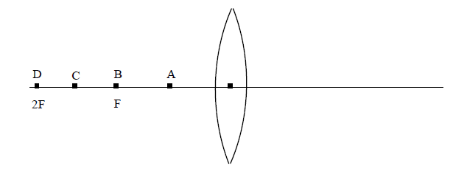
(a) A (b) B (c) C (d) D
Q. No.10. In order to make their own food, plant leaves absorb
(a) Minerals (b) Oxygen (c) Rain (d) Sunlight
Q. No.11. Cold blood group of animals is
(a) Crocodile, Ostrich (b) Ostrich, Kiwi
(c) Sparrow, Crocodile (d) Tortoise, Crocodile
Q. No.12. Current can pass through
(a) Iron (b) Plastic (c) Rubber (d) Wood
Q. No.13. If the potential difference across a bulb is increased from 2 volt to 5volt. Then the quantity of current through the bulb will:
(a) Decrease (b) First decreases then increases
(c) Increase (d) First increases then decreases
Q. No.14. When water boils
(a) Gas becomes solid (b) Liquid becomes solid
(c) Liquid becomes gas (d) Solid becomes liquid
Q. No.15. The depletion of ozone layer is happening in the atmosphere due to
(a) Less industrialization (b) Excessive industrialization
(c) Excessive plantation (d) Excessive use of Pesticides
Q. No.16. Which one of the following is a chemical change:
(a) Boiling of milk (b) Boiling of water
(c) Boiling of egg (d) Melting of ice
Q. No.17. The disease that can transfer to the next generation is
(a) Cholera (b) Hemophila (c) Influenza (d) Malaria
Q. No.18. The thermometer that shows the boiling of water in a Pan is
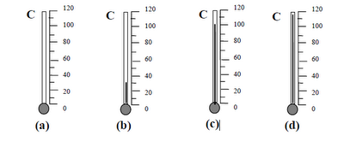
Q. No.19. The symbol of Cobalt is
(a) Cr (b) Co (c) Ca (d) CO
Q. No.20. The Galvanometer will detect current when the magnet is
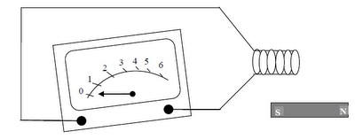
(a) Far away from the coil (b) High above the coil
(c) Moving in the coil (d) below near the coil
Q. No.21. Salt that is used for the treatment of goiter disease is
(a) Iodine (b) Magnesium (c) Potassium (d) Sodium
Q. No.22. When two hydrogen atoms and one oxygen atom combine chemically they form:
(a) Compound (b) Element (c) Ion (d) Mixture
Q. No.23. Diamond is most likely used in making of
(a) Bangles (b) Electrode
(c) Jewellery (d) Electric bulb
Q. No.24. Chromoses are chemically composed of DNA and
(a) Carbohydrates (b) Fats
(c) Protein (d) Vitamins
Q. No.25. Example of Non-Crystalline forms of carbon is
(a) Charcoal and Coal (b) Charcoal and Bucky ball
(c) Coal and Graphite (d) Coke and Diamond
Q. No.26. The group of dicotyliden plants is
(a)Apple, Pea, Maize (b) Pea, Rose, Orange
(c) Rice, Apple, Sarsoon (d) Wheat, Mango, Sugarcane
Q. No.27. Soap is prepared by heating the mixture of
(a) Animal fat and Sodium Bicarbonate
(b) Vegetable oil and Sodium Carbonate
(c) Vegetable oil and Animal fat
(d) Vegetable oil and Sodium Hydro oxide
Q. No.28. Conefers are the plants which have
(a) Cones and small leaves (b) Naked seeds and Needle leaves
(c) Naked seeds but no leaves (d) Seeds and flowers
Q. No.29. If you dip your finger inside a liquid. The pressure exerted by the liquid on your finger would be
(a) Different at all parts (b) Minimum on lower part
(c) Maximum on upper part (d) Same at all parts
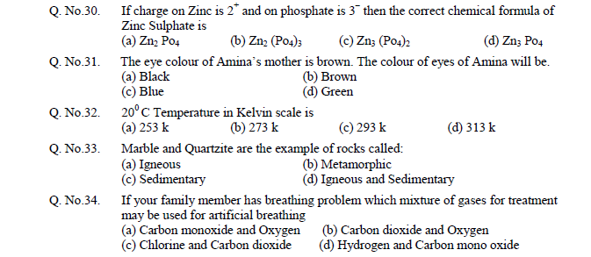
Q. No.35. Comets revolve around the
(a) Earth (b) Moon (c) Sun (d) Star
Q. No.36. If two ends of a bulb are connected with the positive terminal of the battery, the bulb will
(a) be lighted (b) be Fused (c) First lighted then fused (d) not lighted
Q. No.37. Solids ionic compound behaves at normal temperature as
(a) Conductor (b) Insulator
(c) Semi-Conductor (d) Super Conductor
Q. No.38. One of your class fellows has fungus problem on his skin which substance will be applied along with sulphur for treatment
(a) Calcium Hydro oxide (b) Calcium Oxide
(c) Sodium Carbonate (d) Sodium Hydro oxide
Q. No.39. Na2CO3 represents the chemical formula of
(a) Barium Carbonate (b) Calcium Carbonate
(c) Potassium Carbonate (d) Sodium Carbonate
Q. No.40. When a light ray enters from lighter medium to denser medium at right angle, it
(a) Bends towards normal (b) Bends away from normal
(c) Does not change its path (d) Reflects back in lighter Medium

